**DynamoDB Assignment**

**Problem Statement:**

**You work for XYZ Corporation. Their application requires a database service that can store data which can be retrieved if required. Implement a suitable service for the same. While migrating, you are asked to perform the following**

**tasks:**

**1. Create a DynamoDB table with partition key as ID.**

**2. Add 5 items to the DynamoDB table.**

**3. Take backup and delete the table.**

1. Create a DynamoDB table with partition key as ID.

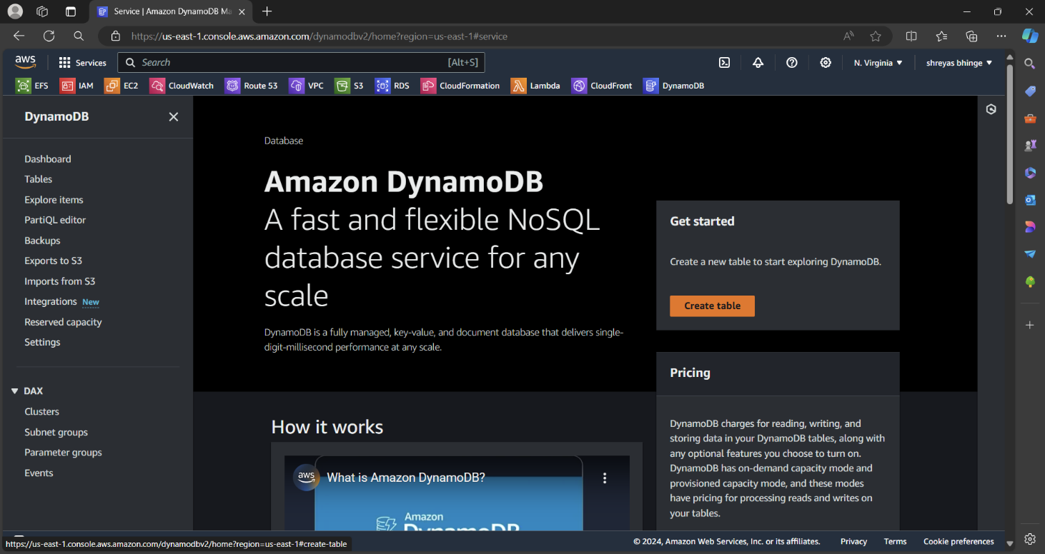

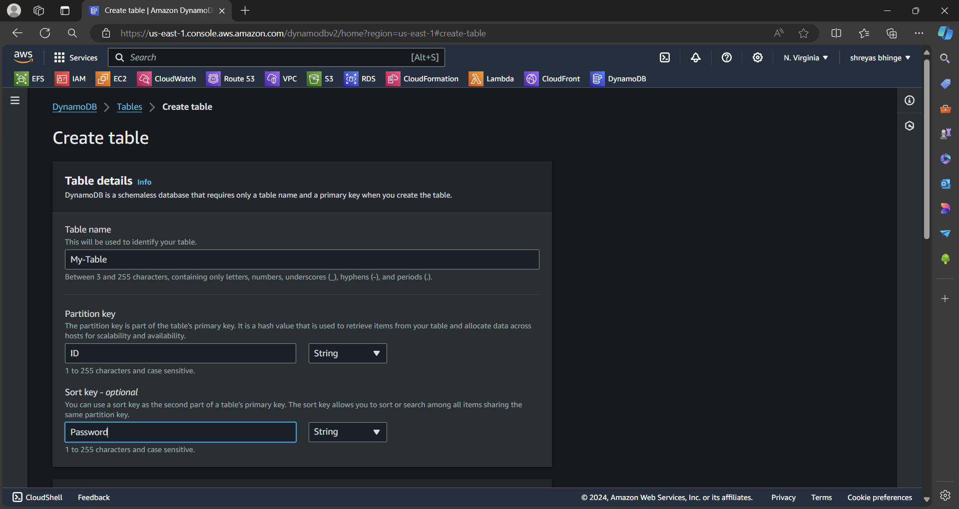

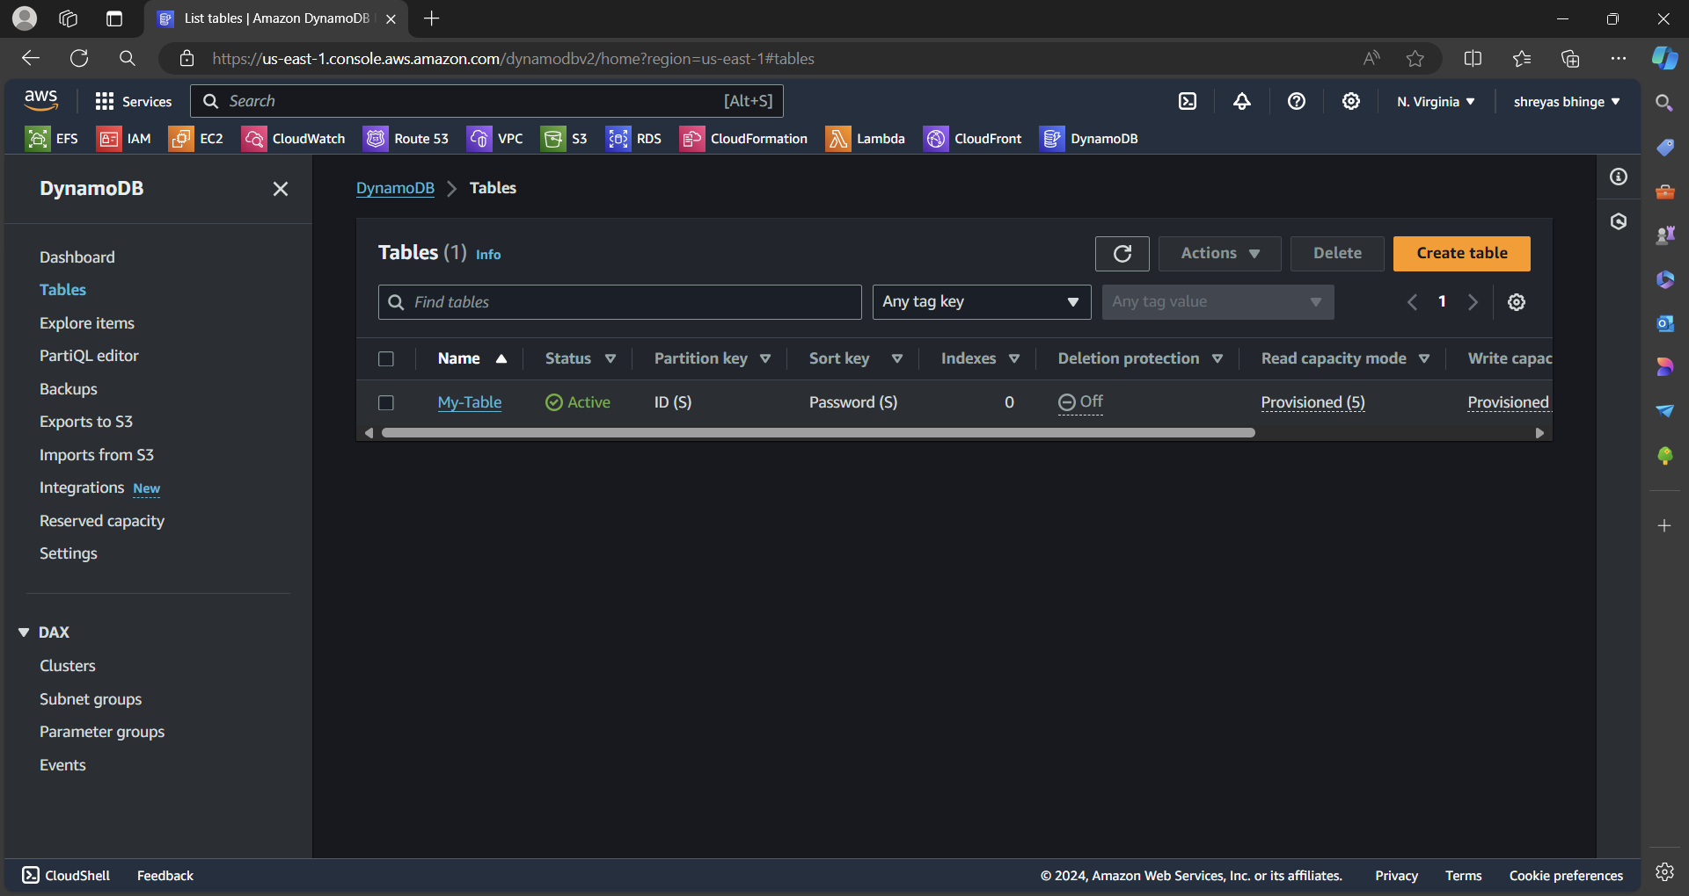

2. Add 5 items to the DynamoDB table.

* Check on Explore Table
* Created 5 items

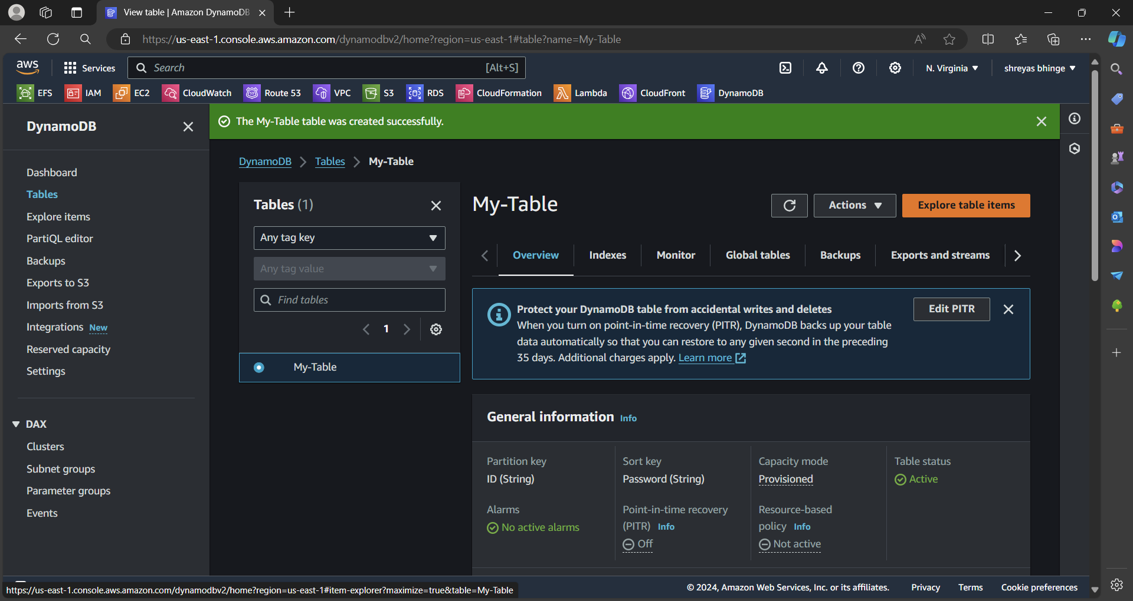

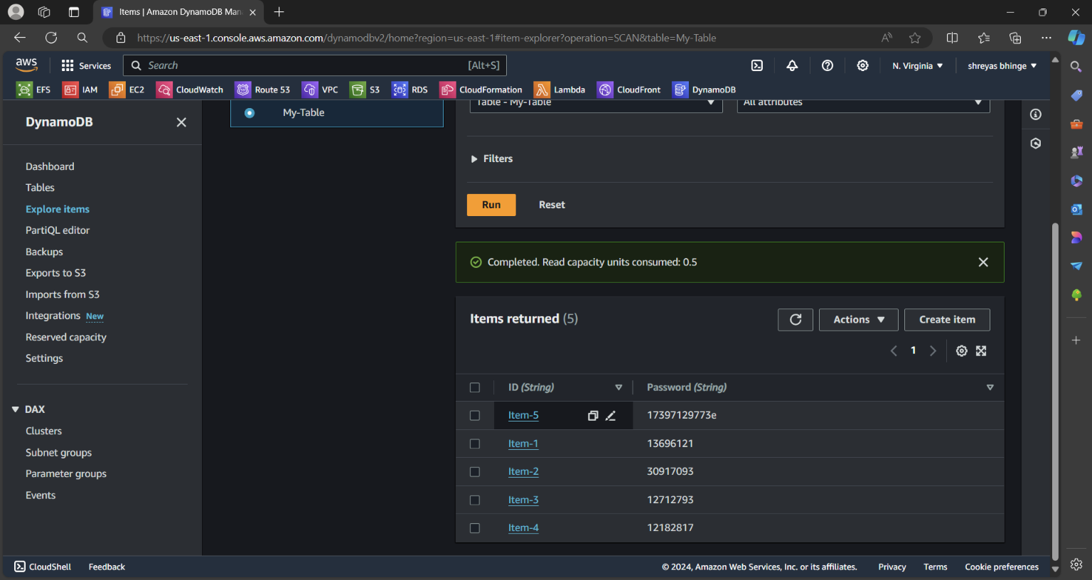

3. Take backup and delete the table

* Inside Table Go to Back section
* Check on create backup and backup gets created

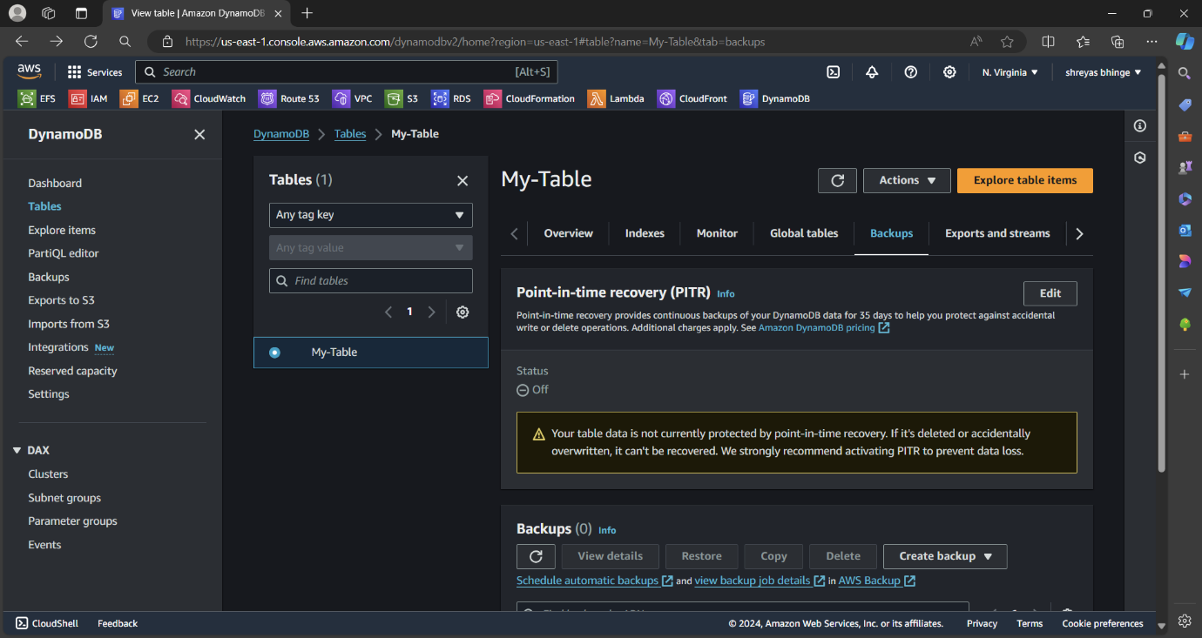

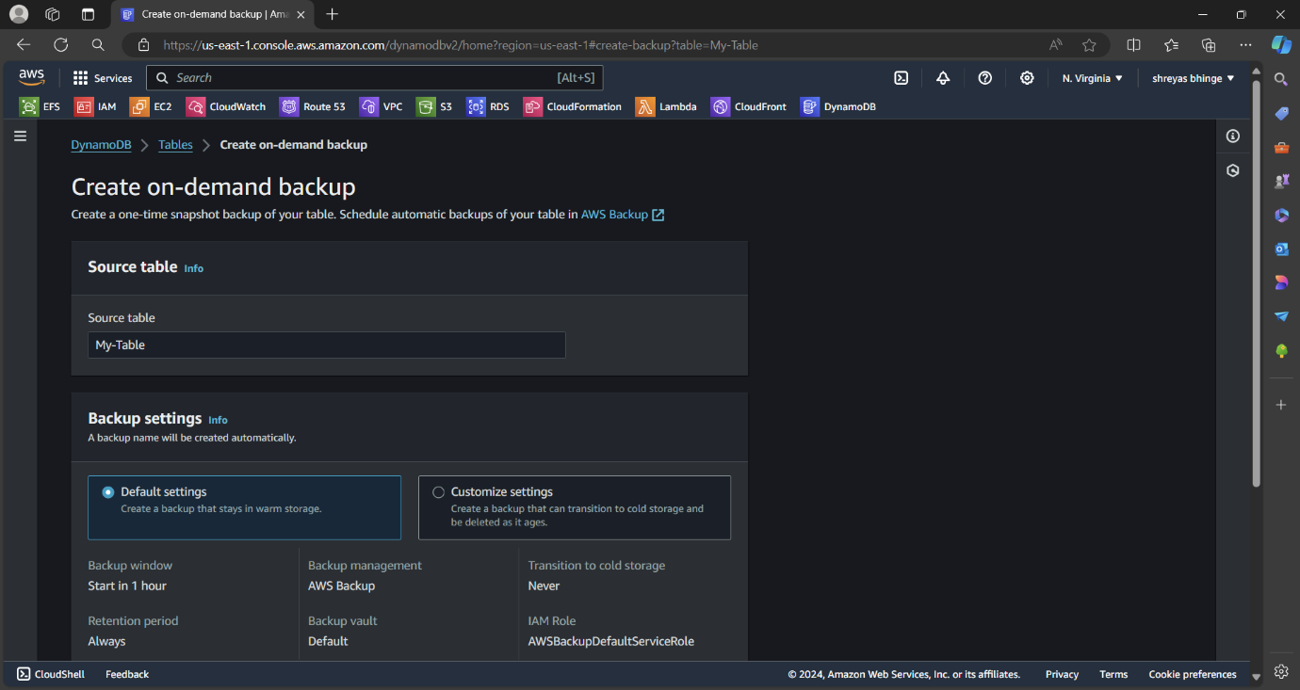

**Deleted the Table**

